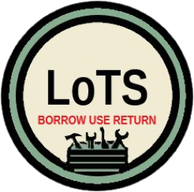
Volunteer Induction Form
Library of Things Saltburn

Date of interview
Interviewed by
Name
DOB*
Email
Phone number
Address
Medical needs
Other support needs
Next of Kin name
Next of kin phone
Availability

I have read the volunteer information pack and agree to follow the guidelines.
Signed: Date:
I am happy to work alone at the Library of things*
Signed: Date:
*You do not have to agree to lone working. If you do not wish to do this we are very happy for you to work alongside another volunteer.

Equalities monitoring, You don’t have to tell us these but it helps us to make sure we are recruiting from our whole community.
Gender
Ethnicity
DOB

