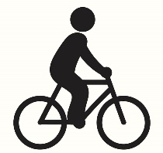 | Lets Go Cycling  Volunteer Application Form

Personal Details

Name

Address | Postcode:
Phone | Home:  Mobile:  Emergency Contact:
Email

Please tell us about any relevant previous experience i.e. coaching, working with children, SEN (special educational needs) or vulnerable adults.

Availability
At what times are you interested in volunteering – please tick as many as you like
Mon | Tues | Wed | Thurs | Fri | Sat | Sun

Please note: As the role may involve working will young persons or vulnerable adults an Enhanced DBS check will be required for all volunteer roles (free of charge).

References

To complete your application, we need you to supply us with two people who know you well enough to comment on your suitability for this role. They should not be family members. Please contact us if you require advice regarding referee selection.

Referee 1

Name:

Address: | Postcode:
Phone:

Email:

How does this person know you?

Referee 2

Name:

Address: | Postcode:
Phone:

Email:

How does this person know you?

If your volunteering role falls within the Rehabilitation of Offenders Act 1974 or is a specified or regulated activity, we will require you to a DBS check.
Having a criminal record will not necessarily exclude you from volunteering with us and your application will be dependent on the nature of the offence and position applied for. Self-declaration will only be required if you are short listed.

Signed

*Information recoded on this form will be regarded as confidential and retained in accordance with General Data Protection Regulation (GDPR) 2018.

